# **Critical Care Database**

1. Write a query to count the number of columns in the nursing chart table.

**QUERY:**

SELECT COUNT(*) as no_of_columns

/* information_schema.columns contain metadata which stores all columns in all table of the database.*/

FROM information_schema.columns

WHERE table_name = 'nursingchart' AND table_schema = 'public';

**OUTPUT:**

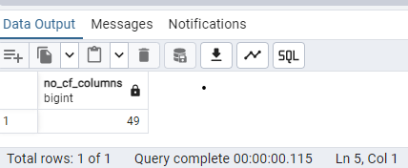

2. Using a recursive query, show a list of patients that were transferred to various departments after they were admitted, along with the departments and the time of transfer. Hint, use earliest start time as time of admission

**QUERY:**

WITH RECURSIVE Transfer_Report AS (

-- STEP 1: Identify the Base Case (First Transfer as Admission)

SELECT

t.patient_id,

t.transferDept AS Department,

t.starttime AS Transfer_Time,

1 AS level -- used to initialize the recursion for each patient

FROM transfer t

JOIN baseline b

ON t.patient_id = b.patient_id

WHERE t.starttime = (

SELECT min(starttime)

FROM transfer

WHERE patient_id = t.patient_id

)

-- STEP 2: Recursive Case - Find Subsequent Transfers

UNION ALL

SELECT

t.patient_id,

t.transferdept AS Department,

t.starttime AS Transfer_Time,

TR.level + 1 AS level -- This increments the level for subsequent transfers

FROM transfer t

JOIN Transfer_Report TR

ON t.patient_id = TR.patient_id

WHERE t.starttime > TR.Transfer_Time

AND TR.level < 5 -- Recursion depth limit

)

-- STEP 3: Apply ROW_NUMBER to ensure unique records

SELECT

patient_id,

Department,

Transfer_Time

FROM (

SELECT

patient_id,

Department,

Transfer_Time,

ROW_NUMBER() OVER (PARTITION BY patient_id,Transfer_Time ORDER BY Transfer_Time) AS row_num

FROM Transfer_Report

) AS Transfer_Rank

WHERE row_num =1 ---select only the first transfer per patient

ORDER BY patient_id, Transfer_Time;

**OUTPUT:**

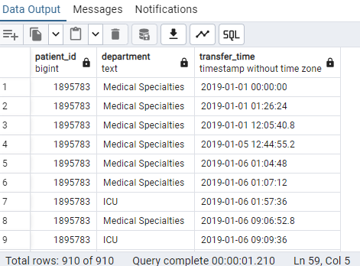

NOTE:

TR.level < 5 ensures that recursion doesn't continue endlessly, limiting the query to a reasonable depth.

By using **ROW_NUMBER()**, this query ensures that it returns only the **first department and transfer time** after admission for each patient, eliminating duplicates and maintaining a unique list of transfers.

3. List all patients who had a systolic blood pressure higher than the median value in the ICU.

Use windows functions to achieve this.

**QUERY:**

-- STEP 1: Rank the SBP values for all patients

WITH RankSBP AS (

SELECT

b.patient_id,

n.invasive_sbp AS SBP,

ROW_NUMBER() OVER (ORDER BY n.invasive_sbp) AS row_num, -- Assign unique ranks

COUNT(*) OVER() AS total_count

FROM nursingchart n

JOIN baseline b ON n.inp_no = b.inp_no

WHERE n.invasive_sbp IS NOT NULL

AND b.admitdept = 'ICU'

),

-- STEP 2: Identify median SBP value

MedianSBP AS (

SELECT

total_count,

CASE

WHEN total_count % 2 = 1 THEN

MAX(CASE WHEN row_num = (total_count + 1) / 2 THEN SBP END) -- Odd count, single middle value

ELSE

AVG(CASE WHEN row_num IN (total_count / 2, total_count / 2 + 1) THEN SBP END) -- Even count, average of two middle values

END AS median_value

FROM RankSBP

GROUP BY total_count

)

-- STEP 3: Retrieve rows where SBP is higher than the median

SELECT DISTINCT

r.patient_id,

r.SBP

FROM RankSBP r

CROSS JOIN MedianSBP m

WHERE r.SBP > m.median_value

ORDER BY r.SBP;

**OUTPUT:**

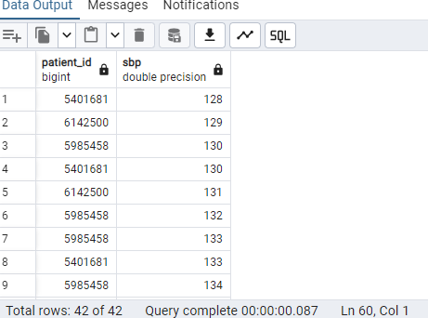

**NOTE:To filter the systolic blood pressure (SBP) values as requested in the task, I have used the invasive_sbp field instead of other blood pressure metrics. This choice was made because the question specifically focuses on ICU patients, and invasive_sbp is the standard and relevant measurement for blood pressure in ICU settings. Hence, only the invasive_sbp data is used in this query to align with the ICU context.**

4. Create a function to fetch the details of the last recorded drug for a patient

**QUERY:**

-- STEP 1: Define the function signature

CREATE OR REPLACE FUNCTION last_recorded_drug_details()

RETURNS TABLE(patient_id INT,drugname VARCHAR, formula VARCHAR, drug_time TIMESTAMP)

AS $$

--STEP 2: Begin the function definition

BEGIN

-- STEP 3: Write the query to fetch the last recorded drug

RETURN QUERY

SELECT

d.patient_id::INT,

d.drugname::VARCHAR, -- Casting to VARCHAR

d.formula::VARCHAR, -- Casting to VARCHAR

d.drug_time::TIMESTAMP -- Casting to TIMESTAMP

FROM drugs d

ORDER BY d.drug_time DESC

LIMIT 1;

-- STEP 4: End the function definition

END;

-- STEP 5: Specify the language

$$ LANGUAGE plpgsql;

**OUTPUT:**

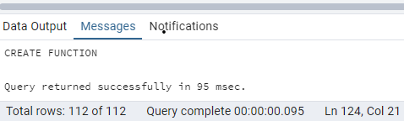

STEP 6: Call the function to execute it

**QUERY:**

SELECT * FROM last_recorded_drug_details();

**OUTPUT:**

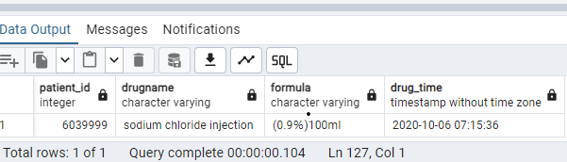

5. List the 5 most recent transfers.

**QUERY:**

SELECT * FROM transfer

ORDER BY starttime DESC –Sorts the results by the starttime column in descending order, so the most recent transfers appear first.

LIMIT 5; –Limits the output to the top 5 rows.

**OUTPUT:**

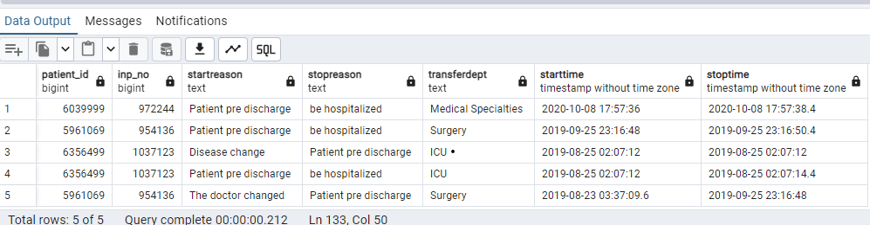

6. Use a window function to calculate the rolling average of heart rate for each patient.

**QUERY:**

WITH RollingAverage AS (

SELECT

b.patient_id,

n.charttime,

n.heart_rate,

AVG(n.heart_rate) OVER (PARTITION BY b.patient_id ORDER BY n.charttime ROWS BETWEEN UNBOUNDED PRECEDING AND CURRENT ROW

) AS Rolling_Avg_Heart_Rate,

ROW_NUMBER() OVER (PARTITION BY b.patient_id ORDER BY n.charttime DESC

) AS row_num

FROM

nursingchart n

JOIN

baseline b

ON

b.inp_no = n.inp_no

WHERE

n.heart_rate IS NOT NULL

)

SELECT

patient_id,

charttime,

heart_rate,

Rolling_Avg_Heart_Rate

FROM

RollingAverage

WHERE

row_num = 1

ORDER BY

patient_id;

**OUTPUT:**

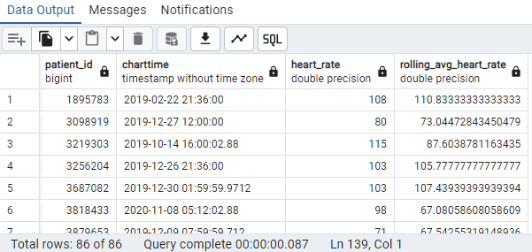

7. List patients who were transferred back into surgery after they were discharged.

**QUERY:**

SELECT DISTINCT

t.patient_id

FROM Transfer t

JOIN Baseline b ON b.PATIENT_ID = t.PATIENT_ID

WHERE

t.TransferDept = 'Surgery' -- Transfer to surgery

AND t.StartTime > b.ICU_discharge_time

ORDER BY t.PATIENT_ID;

**OUTPUT:**

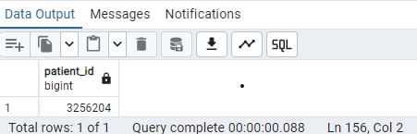

8.Find the average age in each department by gender.

**QUERY:**

SELECT ROUND(AVG(age)) As average_age, sex, admitdept ----Round function used to round the nearest whole number.

FROM baseline

GROUP BY admitdept,sex

ORDER BY average_age;

**OUTPUT:**

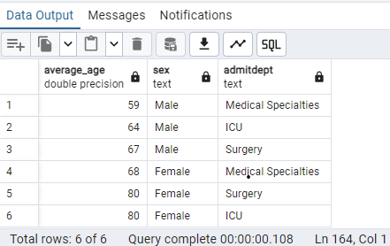

9. Show all patients whose blood sugar is in the 99th percentile, and the time when it was recorded.

**QUERY:**

SELECT DISTINCT ON (b.patient_id) ---distinct on used to remove the dulpicate records of patient and time

b.patient_id,

n.charttime,

n.blood_sugar

FROM nursingchart n

JOIN baseline b ON b.inp_no = n.inp_no

WHERE n.blood_sugar >= (

SELECT PERCENTILE_CONT(0.99) WITHIN GROUP (ORDER BY blood_sugar) AS Percentile_99 ---calculate 99th perentile for blood sugar

FROM nursingchart

)

ORDER BY b.patient_id, n.charttime;

**OUTPUT:**

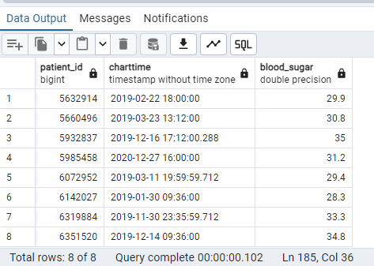

10.Show the last 6 letters of disease names.

**QUERY:**

SELECT DISTINCT RIGHT(REGEXP_REPLACE(icd_desc,'[^a-zA-Z]','', 'g'),6) As last_six_letter_of_disease_names

---REGEXP used to remove non-aplhabetic characters

FROM icd

**OUTPUT:**

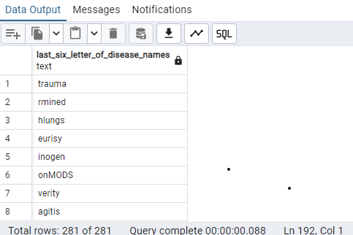

11.Show the most commonly administered drug for each department, and the number of times it was administered. Use windows function to achieve this.

**QUERY:**

WITH RankedDrugs As (

SELECT d.drugname,b.admitdept,

COUNT(d.drug_time) As drug_administrated_count,

RANK() OVER (PARTITION BY b.admitdept ORDER BY COUNT(d.drug_time) DESC) As rank

FROM drugs d

JOIN baseline b ON b.patient_id =d.patient_id

GROUP BY b.admitdept,d.drugname

)

SELECT drugname As commonly_administrated_drug, admitdept, drug_administrated_count

FROM RankedDrugs

WHERE rank = 1 ----most commonly administered drugs in each department

ORDER BY admitdept;

**OUTPUT:**

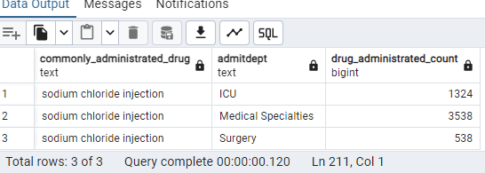

12.Show the position of the letter y in disease name if it exists.

**QUERY:**

SELECT DISTINCT icd_desc,

POSITION('y' IN icd_desc) AS position_of_letter_y

FROM icd

WHERE POSITION('y' IN icd_desc) > 0;

**OUTPUT:**

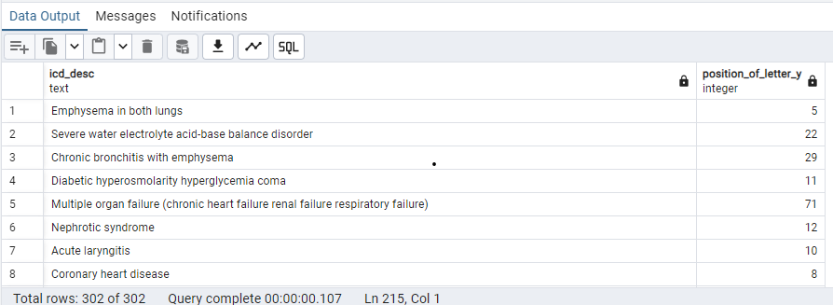

13. Using windows function rank and display the 3 oldest patients admitted into each department.

**QUERY:**

WITH Rank_Oldest_patient AS (

SELECT patient_id, age As patient_age,admitdept,

RANK() OVER(PARTITION BY admitdept ORDER BY age DESC) As rankage

FROM baseline

)

SELECT patient_id, patient_age As Oldest_Patient_age,admitdept

FROM Rank_Oldest_Patient

WHERE rankage<=3 ---provide top 3 patient for each department

ORDER BY admitdept,rankage

**OUTPUT:**

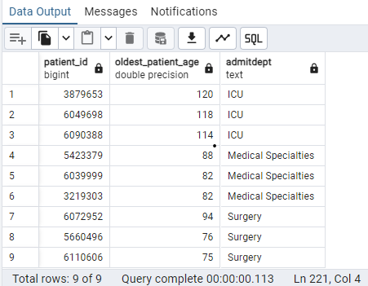

14. Show the number of patients that were discharged in 2020.

**QUERY:**

SELECT COUNT(patient_id) As no_of_patient_discharged

FROM baseline

WHERE EXTRACT(YEAR FROM icu_discharge_time) = 2020;

**OUTPUT:**

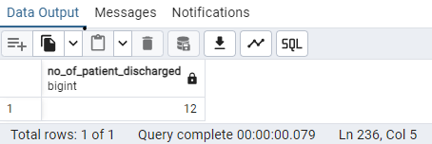

15.Show the total ICU stay in days for each patient who was transferred at least once.

**QUERY:**

SELECT patient_id,

ROUND(SUM(EXTRACT(EPOCH FROM stoptime - starttime) / 86400), 2) AS Total_ICU_Stay

FROM transfer

WHERE transferdept = 'ICU'

GROUP BY patient_id

HAVING COUNT(*) > 0

ORDER BY patient_id;

**OUTPUT:**

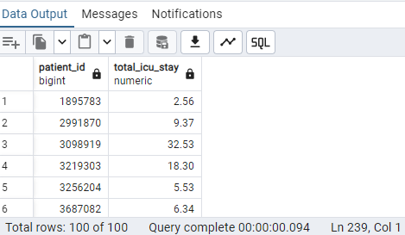

16.Find the average, minimum, and maximum systolic blood pressure for patients in each department.

**QUERY:**

SELECT

b.admitdept AS department,

ROUND(AVG(COALESCE(n.blood_pressure_high, n.invasive_sbp))::NUMERIC,2) AS avg_systolic_bp,

MIN(COALESCE(n.blood_pressure_high, n.invasive_sbp)) AS min_systolic_bp,

MAX(COALESCE(n.blood_pressure_high, n.invasive_sbp)) AS max_systolic_bp

FROM

nursingchart n

JOIN

baseline b ON n.inp_no = b.inp_no

WHERE

COALESCE(n.blood_pressure_high, n.invasive_sbp) > 0

GROUP BY

b.admitdept

ORDER BY

b.admitdept;

**OUTPUT:**

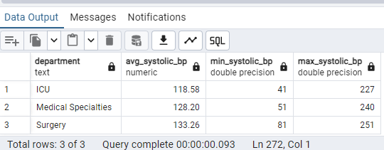

17. Write a stored procedure to calculate the total number of patients per department and return the results as a table.

**QUERY:**

DROP TABLE IF EXISTS PatientRecords ;

-- Step 1: Create the permanent table to store results

CREATE TABLE PatientRecords (

Patient_Count INT,

Department TEXT

);

**OUTPUT:**

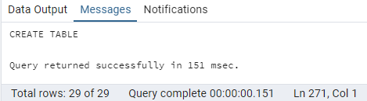

-- Step 2: Create the stored procedure

**QUERY:**

CREATE OR REPLACE PROCEDURE Patient_Department_Details()

LANGUAGE plpgsql

AS $$

BEGIN

-- Insert the data into the Created table

INSERT INTO PatientRecords (Patient_Count, Department)

SELECT COUNT(patient_id) AS Patient_Count, admitdept AS Department

FROM baseline

GROUP BY admitdept

ORDER BY Patient_Count DESC;

-- Raise a notice for confirmation

RAISE NOTICE 'Patient count per department has been updated in Patient_Records.';

END;

$$;

**OUTPUT:**

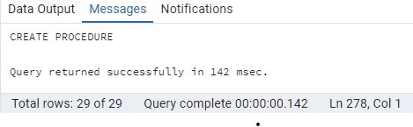

-- Step 3: Call the procedure to populate the table

**QUERY:**

CALL Patient_Department_Details();

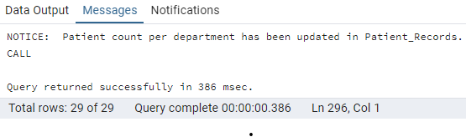

-- Step 4: Retrieve the result

**QUERY:**

SELECT * FROM PatientRecords;

**OUTPUT:**

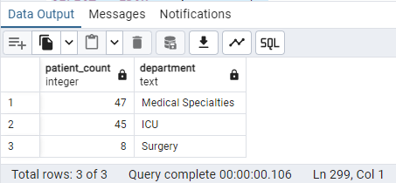

18.Show the top 3 patients who went into surgery the most number of times

**QUERY:**

SELECT patient_id,COUNT(transferdept) As No_of_times_in_Surgery

FROM transfer

WHERE transferdept = 'Surgery'

GROUP BY patient_id

ORDER BY No_of_times_in_Surgery DESC,patient_id

LIMIT 3

**OUTPUT:**

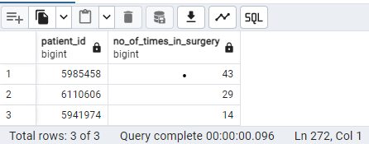

19. Show patients whose critical-care pain observation tool score is 0.

**QUERY:**

SELECT DISTINCT b.patient_id,

n.Cpot_pain_score AS Critical_care_pain_observation_score

FROM nursingchart n

JOIN baseline b

ON n.inp_no = b.inp_no

WHERE CAST(n.Cpot_pain_score As INT) = 0 ---cpot_pain_score column can be compared as an integer.

AND n.Cpot_pain_score IS NOT NULL

ORDER BY b.patient_id;

**OUTPUT:**

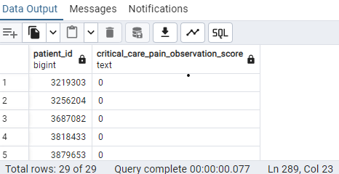

20.Use windows functions to find BP measurements for 3 consecutive days.

List all patients who experienced a drop in blood pressure measurements for 3 continuous days.

**QUERY:**

WITH consecutive_days AS (

SELECT

b.patient_id,

DATE(n.charttime) AS reading_date,

COALESCE( n.blood_pressure_high,n.invasive_sbp) AS high_bp,

COALESCE( n.blood_pressure_low,n.invasive_diastolic_blood_pressure) AS low_bp,

LAG(DATE(n.charttime)) OVER (PARTITION BY b.patient_id ORDER BY DATE(n.charttime)) AS one_day_ago_date,

LAG(COALESCE(n.blood_pressure_low,n.invasive_diastolic_blood_pressure)) OVER (PARTITION BY b.patient_id ORDER BY DATE(n.charttime)) AS one_day_ago_bp_low,

LAG(COALESCE(n.blood_pressure_high,n.invasive_sbp)) OVER (PARTITION BY b.patient_id ORDER BY DATE(n.charttime)) AS one_day_ago_bp_high,

LAG(DATE(n.charttime), 2) OVER (PARTITION BY b.patient_id ORDER BY DATE(n.charttime)) AS two_days_ago_date,

LAG(COALESCE(n.blood_pressure_low,n.invasive_diastolic_blood_pressure, 2)) OVER (PARTITION BY b.patient_id ORDER BY DATE(n.charttime)) AS two_days_ago_bp_low,

LAG(COALESCE(n.blood_pressure_high,n.invasive_sbp, 2)) OVER (PARTITION BY b.patient_id ORDER BY DATE(n.charttime)) AS two_days_ago_bp_high

FROM nursingchart n

JOIN baseline b

ON b.inp_no = n.inp_no

WHERE COALESCE( n.blood_pressure_high,n.invasive_sbp) IS NOT NULL AND COALESCE( n.blood_pressure_low,n.invasive_diastolic_blood_pressure) IS NOT NULL

),

drops_over_consecutive_days AS (

SELECT

patient_id,

reading_date,

high_bp,

low_bp,

one_day_ago_date,

one_day_ago_bp_high,

one_day_ago_bp_low,

two_days_ago_date,

two_days_ago_bp_high,

two_days_ago_bp_low

FROM consecutive_days

WHERE

-- Ensure the dates are consecutive

one_day_ago_date = reading_date - INTERVAL '1 day'

AND two_days_ago_date = reading_date - INTERVAL '2 day'

-- Check for a drop in blood pressure over 3 consecutive days

AND high_bp < one_day_ago_bp_high

AND one_day_ago_bp_high < two_days_ago_bp_high

AND low_bp < one_day_ago_bp_low

AND one_day_ago_bp_low < two_days_ago_bp_low

)

SELECT

patient_id,

reading_date,

high_bp,

low_bp,

one_day_ago_date,

one_day_ago_bp_high,

one_day_ago_bp_low,

two_days_ago_date,

two_days_ago_bp_high,

two_days_ago_bp_low,

CASE

WHEN COUNT(*) = 0 THEN 'No records for consecutive days'

ELSE 'Records found for consecutive days'

END AS record_status

FROM drops_over_consecutive_days

GROUP BY patient_id, reading_date, high_bp, low_bp, one_day_ago_date, one_day_ago_bp_high, one_day_ago_bp_low, two_days_ago_date, two_days_ago_bp_high, two_days_ago_bp_low

UNION ALL

SELECT

NULL AS patient_id,

NULL AS reading_date,

NULL AS high_bp,

NULL AS low_bp,

NULL AS one_day_ago_date,

NULL AS one_day_ago_bp_high,

NULL AS one_day_ago_bp_low,

NULL AS two_days_ago_date,

NULL AS two_days_ago_bp_high,

NULL AS two_days_ago_bp_low,

'No records for consecutive days' AS record_status

FROM (SELECT 1) AS no_data_check

WHERE NOT EXISTS (SELECT 1 FROM drops_over_consecutive_days)

ORDER BY patient_id;

**OUTPUT:**

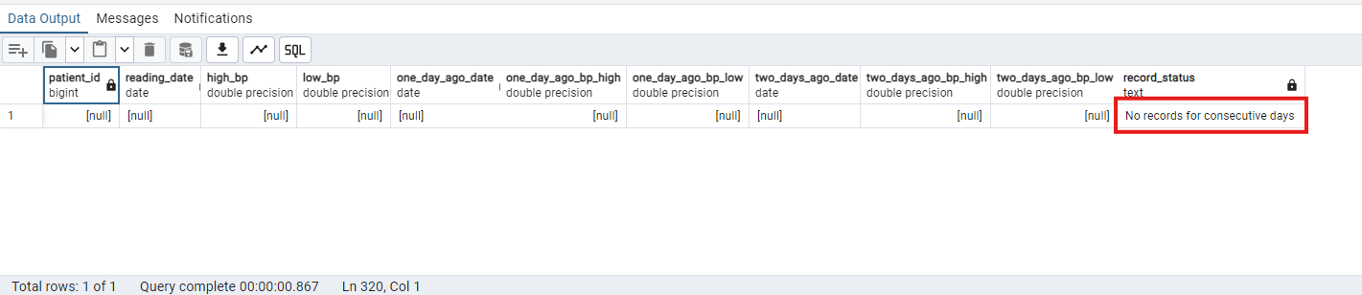

**NOTE:**  No records for consecutive days with a significant drop in blood pressure for any patient, indicating no matching data in the dataset.

21. How was general health of patients who had a breathing rate > 20?

**QUERY:**

SELECT distinct outcome.patient_id AS "Patien ID",

nursingchart.inp_no AS "Inp No",

outcome.sf36_generalhealth AS "generaihealth",

nursingchart.breathing

FROM outcome

JOIN baseline ON baseline.patient_id = outcome.patient_id

JOIN nursingchart On nursingchart.inp_no = baseline.inp_no

WHERE breathing >20

GROUP BY outcome.patient_id, outcome.sf36_generalhealth, nursingchart.breathing, nursingchart.inp_no;

**OUTPUT:**

22. List patients with heart_rate more than two standard deviations from the average.

**QUERY:**

SELECT DISTINCT baseline.patient_id , nursingchart.heart_rate

FROM baseline

JOIN nursingchart on nursingchart.inp_no = baseline.inp_no

WHERE nursingchart.heart_rate > (SELECT AVG(heart_rate) + 2 * STDDEV(heart_rate)

FROM nursingchart)

OR nursingchart.heart_rate <(SELECT AVG(heart_rate) - 2 * STDDEV(heart_rate)

FROM nursingchart**);**

**OUTPUT**

23. Create a trigger to raise notice and prevent deletion of a record from baseline table.

**QUERY:**

CREATE OR REPLACE FUNCTION prevent_deletion()

RETURNS TRIGGER AS $$

BEGIN

RAISE NOTICE 'Deletion of Records Not Allowed ';

RETURN NULL;

END;

$$

LANGUAGE plpgsql;

**OUTPUT**

CREATE TRIGGER deletion_not_allowed

BEFORE DELETE ON baseline

FOR EACH ROW

EXECUTE PROCEDURE prevent_deletion();

**QUERY TO VERIFY TRIGGER**

DELETE FROM baseline

WHERE patient_ID = 6291268;

**OUTPUT:**

24. Use a CTE to get all patients with temperature readings above 38.

**QUERY:**

WITH Temperature_Recording AS (

SELECT DISTINCT baseline.patient_id,

nursingchart.temperature

FROM nursingchart

JOIN baseline On baseline.inp_no = nursingchart.inp_no

WHERE nursingchart.temperature > 38

)

SELECT * FROM Temperature_Recording

**OUTPUT:**

25. Develop a stored procedure to insert a new patient into the patients table and return the new patient ID.

**QUERY:**

CREATE OR REPLACE PROCEDURE insert_new_patient(

--b_patient_id bigint,

b_inp_no bigint,

b_age integer,

b_sex text,

b_admindept text,

b_infectionsite text,

b_patient_id OUT bigint

)

LANGUAGE plpgsql

AS $$

DECLARE

M_PATIENT_ID bigint;

BEGIN

SELECT INTO M_PATIENT_ID MAX(Patient_ID)+1 from baseline;

INSERT INTO baseline (PATIENT_ID, inp_no,age,sex,admitdept,infectionsite,icu_discharge_time)

VALUES(m_patient_ID, b_inp_no,b_age,b_sex,b_admindept,b_infectionsite,CURRENT_DATE);

b_patient_id:=M_PATIENT_ID;

END;

$$;

**OUTPUT: 1**

**QUERY:2**

**EXECUTE PROCEDURE:**

CALL insert_new_patient(

100000,90,'Male','icu','Liver', null --6357027

);

**OUTPUT: 2**

26. Find a correlation between blood sugar levels and discharge time from ICU.

**QUERY:**

SELECT

CORR (blood_sugar,(DATE_PART('HOUR',(ICU_discharge_time))))

AS correlation

FROM

baseline

JOIN nursingchart ON nursingchart.inp_no = baseline.inp_no;

**OUTPUT:**

27. Divide the patients into 3 age groups.

**QUERY:**

SELECT

CASE

WHEN age < 18 THEN 'Child(0-17)'

WHEN age BETWEEN 18 AND 64 THEN 'Adult(18-64)'

ELSE 'Senior (65+)'

END AS AgeGroup, *

FROM baseline

ORDER BY ageGroup;

**OUTPUT:**

28. Show the hour(as a time slot like 9 AM - 10 AM) when least discharges happen.

**QUERY:**

SELECT COUNT(PATIENT_ID) AS DISCHARGE_COUNT,

concat(DATE_PART('HOUR',(ICU_discharge_time)),' Oclock to ',(DATE_PART('HOUR',(ICU_discharge_time))+1),' Oclock' )

AS Time_Range

FROM baseline

GROUP BY DATE_PART('HOUR',(ICU_discharge_time))

ORDER BY DISCHARGE_COUNT ASC;

**OUTPUT:**

29. Display 3 random patients who had UTI.

**QUERY:**

SELECT infectionsite,patient_id

FROM baseline

WHERE infectionsite = 'UTI'

ORDER BY RANDOM()

LIMIT 3 ;

**OUTPUT:**

30. List the average length of stay for patients diagnosed with soft tissue infections.

**QUERY**:

SELECT baseline.InfectionSite,

AVG(Age(baseline.icu_discharge_time, StartTime)) AS average_stays

FROM transfer

JOIN baseline ON baseline.inp_no = transfer.inp_no

WHERE InfectionSite = 'Soft Tissue' and startreason= 'Admission'

GROUP BY baseline.InfectionSite;

**OUTPUT:**

31. Create a table called Patient1952 to store all patients born in 1952 with their age and and sex info.

**QUERY**:

Create TABLE Patient1952

AS

SELECT Patient_ID, Age,sex

FROM baseline

WHERE EXTRACT('YEAR' FROM (CURRENT_DATE - CAST (age*365 AS INTEGER)))=1952;

**OUTPUT:1**

**QUERY TO CHECK THE VIEW**

SELECT * FROM Patient1952;

**OUTPUT:2**

32. Give the highest temperature, and highest heart rate recorded of all the patients

in surgery for each day.

**QUERY**:

SELECT

DATE(nursingchart.charttime )AS DATE,

MAX(nursingchart.temperature) AS highest_temprature,

MAX(nursingchart.heart_rate ) AS highest_heart_rate,

transfer.patient_id

FROM

transfer

JOIN nursingchart ON nursingchart.inp_no = transfer.inp_no

WHERE UPPER(transfer.transferdept)='SURGERY'

GROUP BY nursingchart.charttime, transfer.patient_id

ORDER BY DATE;

**OUTPUT**

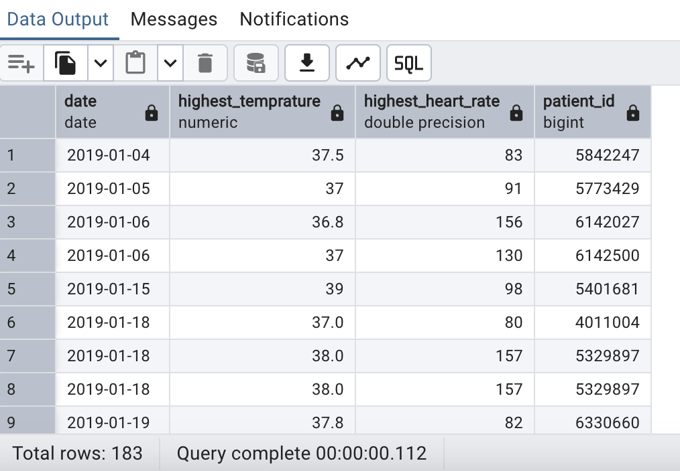

33. List all patients whose heart rate increased by over 30% from the previous reading and the time when it happened.

List all occurences of heart rate increase. Use Windows functions to achieve this.

**QUERY**

SELECT CAST(((Test.heart_rate - TEst.prev_heart_rate) / TEst.prev_heart_rate)* 100 as bigint) AS "%INCREASE", *

FROM

(SELECT

baseline.patient_id,

nursingchart.charttime,

nursingchart.heart_rate,

LAG(nursingchart.heart_rate)OVER (PARTITION BY baseline.patient_id

ORDER BY nursingchart.charttime) prev_heart_rate

FROM nursingchart

JOIN baseline ON baseline.inp_no = nursingchart.inp_no) AS TEst

WHERE

Test.heart_rate IS NOT NULL AND Test.prev_heart_rate <>0

AND TEst.prev_heart_rate IS NOT NULL

AND ((Test.heart_rate - TEst.prev_heart_rate) / TEst.prev_heart_rate)* 100 >30;

**OUTPUT**

34. List patients who had milk and soft food but produced no urine.

**QUERY**

SELECT DISTINCT baseline.patient_id, nursingchart.milk AS milk_intake,

nursingchart.soft_food AS soft_food_intake,

nursingchart.urine_volume

FROM baseline

JOIN nursingchart ON nursingchart.inp_no = baseline.inp_no

WHERE nursingchart.milk >0

AND nursingchart.soft_food >0

AND (urine_volume = 0 or urine_volume IS NULL);

**OUTPUT**

35. Using crosstab, show number of times each patient was transferred to each department.

**QUERY**

CREATE EXTENSION IF NOT EXISTS tablefunc;

SELECT *

FROM CROSSTAB (

'SELECT patient_id,transferdept,COUNT(*) AS transfer_count

FROM transfer

GROUP BY patient_id,transferdept

ORDER BY patient_id,transferdept',

'SELECT DISTINCT transferdept FROM transfer ORDER BY transferdept'

) AS (

patient_id integer,

"ICU" integer,

"MEDICAL SPECIALITIES" integer,

"SURGERY" integer

);

**OUTPUT**

36. Produce a list of 100 normally distributed age values. Set the mean as the 3rd lowest age in the table, and assume the

standard deviation from the mean is 3.

**QUERY**

WITH sorted_ages AS (

SELECT

age,

ROW_NUMBER() OVER (ORDER BY age) AS

row_num

FROM baseline

),

third_lowest_age AS(

SELECT

age AS mean

FROM sorted_ages

WHERE row_num = 3

)

SELECT

ROUND((mean + 3 * sqrt(-2 * lN(RANDOM())) *

cos(2* pi() * RANDOM())) )AS age

FROM

third_lowest_age,

baseline;

**OUTPUT**

37. Display the patients who engage in vigorous physical activity and have no body pain.

**QUERY**

SELECT patient_id,SF36_ActivityLimit_VigorousActivity,

SF36_Pain_BodyPainPast4wk

FROM public.outcome

WHERE sf36_activitylimit_vigorousactivity ='3_not limited at all'

AND UPPER(SF36_Pain_BodyPainPast4wk) ='1_NONE';

**OUTPUT**

38. Create a view on outcome table to show patients with poor health.

**QUERY**

CREATE VIEW poor_health_condition AS

SELECT

patient_id,

sf36_generalhealth

FROM outcome

WHERE UPPER(sf36_generalhealth) ='5_POOR';

**OUTPUT-1**

**QUERY TO VERIFY THE VIEW**

SELECT * FROM poor_health_condition;

**OUTPUT-2**

39. Create a procedure to check if a disease code exists.

**QUERY**

CREATE OR REPLACE PROCEDURE

Check_Disease_Code (patient_disease_code text,

code_exists OUT BOOLEAN )

AS $$

BEGIN

SELECT EXISTS(

SELECT 1

FROM icd

WHERE icd_code = patient_disease_code

)INTO code_exists;

END ;

$$ LANGUAGE plpgsql;

**OUTPUT-1**

**QUERY TO VERIFY THE PROCEDURE**

CALL Check_Disease_Code ('G93.812',null)

**OUTPUT-2**

40. Which drug was most administered among patients who have never been intubated?

**QUERY**

SELECT

drugs.DrugName,

COUNT(*)AS administered_count

FROM drugs WHERE

drugs.patient_id IN (SELECT DISTINCT patient_id

FROM nursingchart

JOIN baseline ON baseline.inp_no = nursingchart.inp_no

WHERE nursingchart.Endotracheal_intubation IS NOT NULL

AND nursingchart.Gastric_tube IS NOT NULL)

GROUP BY drugs.DrugName

order by drugs.DrugName;

**OUTPUT**

1. Add a column birthyear to baseline column based on age.

**Step 1: Add birthyear column to baseline table.**

**QUERY:**

ALTER TABLE baseline ADD COLUMN IF NOT EXISTS birthyear INT;

**OUTPUT :**

**Step 2: Update the birthyear column based on age**

**QUERY:**

UPDATE baseline

SET birthyear = EXTRACT(YEAR FROM CURRENT_DATE) - age;

**OUTPUT :**

**Step 3: Verify if birthyear column updated correctly.**

**QUERY:**

SELECT * FROM baseline;

**OUTPUT:**



1. Use regular expression to find disease names that end in 'itis'.

**QUERY:**

SELECT DISTINCT icd_desc

FROM icd

WHERE icd_desc ~ 'itis$';

**OUTPUT:**



1. Write a stored procedure to generate a summary report for a patient ID specified by user, including blood sugar, temperature, heart rate and drug administration.

**Step 1: Create the stored procedure:**

**QUERY:**

CREATE OR REPLACE PROCEDURE generate_patient_summary(patient_id_input BIGINT)

LANGUAGE plpgsql

AS $$

DECLARE

summary_cursor CURSOR FOR

SELECT

b.patient_id,

b.inp_no,

MAX(n.blood_sugar) AS blood_sugar,

AVG(n.temperature) AS avg_temperature,

AVG(n.heart_rate) AS avg_heart_rate

FROM nursingchart n

JOIN baseline b ON n.inp_no = b.inp_no

WHERE b.patient_id = patient_id_input

GROUP BY b.patient_id, b.inp_no;

drug_cursor CURSOR FOR

SELECT

d.drugname,

d.formula,

d.drug_time

FROM drugs d

WHERE d.patient_id = patient_id_input

ORDER BY d.drug_time DESC;

summary_row RECORD;

drug_row RECORD;

BEGIN

OPEN summary_cursor;

LOOP

FETCH summary_cursor INTO summary_row;

EXIT WHEN NOT FOUND;

RAISE NOTICE 'Patient ID: %, INP No: %, Blood Sugar: %, Avg Temperature: %, Avg Heart Rate: %',

summary_row.patient_id,

summary_row.inp_no,

summary_row.blood_sugar,

ROUND(summary_row.avg_temperature::NUMERIC, 2),

ROUND(summary_row.avg_heart_rate::NUMERIC, 2);

END LOOP;

CLOSE summary_cursor;

RAISE NOTICE '------------------------------------------------------------------------------------------------------';

RAISE NOTICE 'Drug Name Formula Drug Time';

RAISE NOTICE '-------------------------------------------------------------------------------------------------------';

OPEN drug_cursor;

LOOP

FETCH drug_cursor INTO drug_row;

EXIT WHEN NOT FOUND;

RAISE NOTICE '% % %',

RPAD(drug_row.drugname, 35, ' '),

RPAD(drug_row.formula, 30, ' '),

drug_row.drug_time;

END LOOP;

CLOSE drug_cursor;

RAISE NOTICE '---------------------------------------------------------------------------------------------------------';

END;

$$;

**OUTPUT:**

**Step 2: Call the stored procedure:**

**QUERY:**

CALL generate_patient_summary(6291268);

**OUTPUT:**

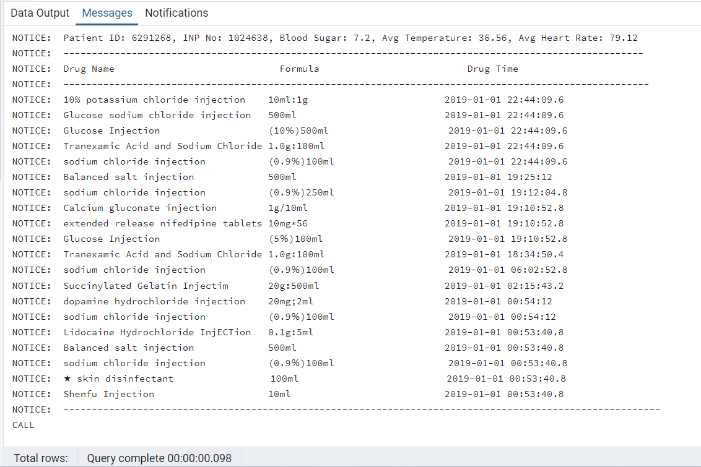



1. Create an index on any column in outcome table and also write a query to delete that index.

**Step 1: Create an index:**

**QUERY:**

CREATE INDEX IF NOT EXISTS idx_outcome_patient_id

ON outcome (patient_id);

**OUTPUT:**

**Step 2: Check if index is created properly:**

**QUERY:**

SELECT indexname, indexdef

FROM pg_indexes

WHERE tablename = 'outcome';

**OUTPUT:**

**Step 3: Drop the index:**

**QUERY:**

DROP INDEX IF EXISTS idx_outcome_patient_id;

**OUTPUT:**

**Step 4: Check if index is dropped properly:**

**QUERY:**

SELECT indexname, indexdef

FROM pg_indexes

WHERE tablename = 'outcome';

**OUTPUT:**



1. Display the sf36_generalhealth of all patients whose blood sugar has a standard deviation of more than 2 from the average.

**QUERY:**

SELECT

o.patient_id,

temp.inp_no,

temp.stddev_blood_sugar,

o.sf36_generalhealth

FROM

(

SELECT inp_no, STDDEV(blood_sugar) AS stddev_blood_sugar

FROM nursingchart

GROUP BY inp_no

)temp

JOIN baseline b ON temp.inp_no = b.inp_no

JOIN outcome o ON b.patient_id = o.patient_id

WHERE temp.stddev_blood_sugar > 2;

**OUTPUT:**



1. Show the average time spent across different departments among alive patients, and among dead patients.

**QUERY:**

SELECT

t.transferdept,

o.follow_vital,

AVG(EXTRACT(EPOCH FROM (t.stoptime - t.starttime)) / 3600) AS avg_hours_spent

FROM transfer t

JOIN outcome o ON t.patient_id = o.patient_id

WHERE o.follow_vital IS NOT NULL

GROUP BY transferdept, follow_vital

ORDER BY transferdept, follow_vital;

**OUTPUT:**



1. Write a query to list all the users in the database.

**QUERY:**

SELECT usename FROM pg_catalog.pg_user;

**OUTPUT:**



1. For each patient, find their maximum blood oxygen saturation while they were in the ICU , and display if it is above or below the average value among all patients.

**QUERY:**

WITH avg_blood_oxygen_saturation AS

(

SELECT AVG(blood_oxygen_saturation) AS avg_blood_oxygen_saturation

FROM nursingchart

),

max_blood_oxygen_saturation_by_patient AS

(

SELECT n.inp_no, MAX(blood_oxygen_saturation) as max_blood_oxygen_saturation

FROM nursingchart n

JOIN baseline b ON n.inp_no = b.inp_no

JOIN transfer t ON b.patient_id = t.patient_id

WHERE t.transferdept = 'ICU'

GROUP BY n.inp_no

)

SELECT inp_no,

max_blood_oxygen_saturation,

avg_blood_oxygen_saturation,

CASE WHEN max_blood_oxygen_saturation > avg_blood_oxygen_saturation

THEN 'Above Average' ELSE 'Below Average' END AS comparison

FROM max_blood_oxygen_saturation_by_patient

CROSS JOIN avg_blood_oxygen_saturation;

**OUTPUT:**



1. For each department, find the percentage of alive patients whose general health was poor after discharge.

**QUERY:**

WITH alive_patients AS (

SELECT discharge_dept, COUNT(*) AS total_alive_patients

FROM outcome

WHERE follow_vital = 'Alive'

GROUP BY discharge_dept

),

poor_health_patients AS (

SELECT discharge_dept, COUNT(*) AS poor_health_count

FROM outcome

WHERE follow_vital = 'Alive' AND sf36_generalhealth = '5_Poor'

GROUP BY discharge_dept

)

SELECT

a.discharge_dept,

a.total_alive_patients,

COALESCE(p.poor_health_count, 0) AS poor_health_count,

ROUND(COALESCE(p.poor_health_count, 0) * 100.0 / a.total_alive_patients, 2) AS percentage_poor_health

FROM

alive_patients a

LEFT JOIN

poor_health_patients p

ON

a.discharge_dept = p.discharge_dept

ORDER BY

a.discharge_dept;

**OUTPUT:**



1. Write a function that takes a date and returns the average temperature recorded for that day.

**Step 1: Create the function:**

**QUERY:**

CREATE OR REPLACE FUNCTION get_avg_temperature_for_date(date DATE)

RETURNS NUMERIC AS $$

DECLARE

avg_temperature NUMERIC;

BEGIN

SELECT ROUND(AVG(temperature),2) INTO avg_temperature

FROM nursingchart

WHERE charttime::DATE = date;

RETURN avg_temperature;

END;

$$ LANGUAGE plpgsql;

**OUTPUT:**

**Step 2 : Execute the function:**

**QUERY:**

SELECT get_avg_temperature_for_date(

'2019-02-23'

);

**OUTPUT:**



1. Show the time spent in ICU for each patient that transferred to ICU from surgery.

**QUERY:**

WITH icu_stay AS (

SELECT

patient_id,

starttime AS icu_start_time,

stoptime AS icu_stop_time

FROM transfer

WHERE transferdept = 'ICU'

),

surgery_stay AS (

SELECT

patient_id,

stoptime AS surgery_stoptime

FROM transfer

WHERE transferdept = 'Surgery'

AND stopreason = 'Transfer'

)

SELECT

i.patient_id,

SUM(EXTRACT(EPOCH FROM i.icu_stop_time - i.icu_start_time) / 3600) AS icu_hours

FROM icu_stay i

JOIN surgery_stay s

ON i.patient_id = s.patient_id

WHERE i.icu_start_time >= s.surgery_stoptime -- Check if patient stayed in ICU after Surgery

GROUP BY i.patient_id;

**OUTPUT:**



1. List all the drugs that were administered between 4 and 5 AM.

**QUERY:**

SELECT DISTINCT drugname

FROM drugs

WHERE drug_time::time BETWEEN '04:00:00' AND '04:59:59';

**OUTPUT:**

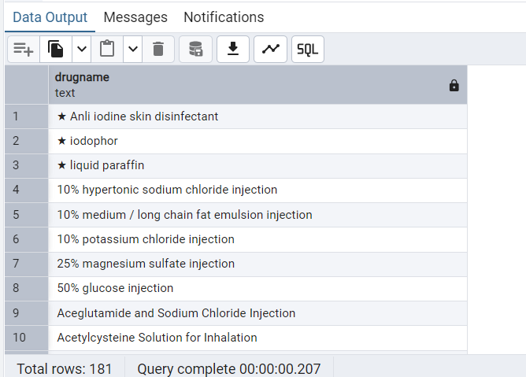



1. Rank each patient based on the number of times they went to ICU.

**QUERY:**

SELECT

  patient_id,

  icu_visits,

  RANK() OVER (ORDER BY icu_visits DESC) AS icu_visits_rank

FROM

(

  SELECT patient_id, COUNT(*) AS icu_visits

  FROM transfer

  WHERE transferdept = 'ICU'

  GROUP BY patient_id

) temp

ORDER BY icu_visits_rank;

**OUTPUT:**



1. Create a function to calculate the percentage of patients admitted into each department.

**Step 1: Create the function:**

**QUERY:**

CREATE OR REPLACE FUNCTION calculate_patient_percentage()

RETURNS TABLE (

department TEXT,

percentage NUMERIC

) AS $$

BEGIN

RETURN QUERY

WITH totalPatients AS (

SELECT COUNT(*)::DECIMAL AS totCount

FROM baseline

),

PatientsByDept AS (

SELECT admitdept, COUNT(patient_id) AS countByDept

FROM baseline

GROUP BY admitdept

)

SELECT

p.admitdept,

ROUND((p.countByDept / t.totCount) * 100,2) AS percentage

FROM PatientsByDept p

CROSS JOIN totalPatients t;

END;

$$ LANGUAGE plpgsql;

**OUTPUT:**

**Step 2: Execute the function:**

**QUERY:**

SELECT * FROM calculate_patient_percentage();

**OUTPUT:**



1. Calculate the variance and standard deviation of oxygen flow readings across different admit departments.

**QUERY:**

SELECT

b.admitdept,

VARIANCE(n.oxygen_flow::NUMERIC) AS variance_oxygen_flow,

STDDEV(n.oxygen_flow::NUMERIC) AS stddev_oxygen_flow

FROM baseline b

JOIN nursingchart n ON b.inp_no = n.inp_no

GROUP BY b.admitdept;

**OUTPUT:**



1. Use a nested query to calculate the max blood_sugar among patients whose average is below 120.

**QUERY:**

SELECT MAX(n.blood_sugar) AS max_blood_sugar

FROM (

SELECT inp_no, AVG(blood_sugar) AS avg_blood_sugar

FROM nursingchart

GROUP BY inp_no

HAVING AVG(blood_sugar) < 120

) temp

JOIN nursingchart n ON temp.inp_no = n.inp_no;

**OUTPUT:**

Note: The lab table also contains blood sugar values for some patients. But it has very limited records, so we are not considering that table. Also, we noticed that there could be some error in the question, as the average blood sugar is around 10.5. A blood sugar value of 120 is considered very high. So, no filtering happens here since all the patients blood sugar is less than 120.



1. List all transfers that started due to a change in disease.

**QUERY:**

SELECT patient_id,

inp_no,

startreason,

stopreason,

transferdept,

starttime,

stoptime

FROM transfer

WHERE startreason = 'Disease change';

**OUTPUT:**



1. Show the number of drugs administered to every patient aged 65 or older.

**QUERY:**

SELECT d.patient_id,COUNT(d.patient_id) AS no_of_drugs

FROM baseline b

JOIN drugs d ON b.patient_id = d.patient_id

WHERE b.age >= 65

GROUP BY d.patient_id

ORDER BY no_of_drugs DESC;

**OUTPUT:**



1. Find the patients report feeling happy all the time.

**QUERY:**

SELECT patient_id, sf36_emotional_happyperson

FROM outcome

WHERE sf36_emotional_happyperson = '1_All of the time';

**OUTPUT:**



1. List the patients that were discharged in December of any year.

**QUERY:**

SELECT patient_id, icu_discharge_time

FROM baseline

WHERE EXTRACT(MONTH FROM icu_discharge_time) = 12;

**OUTPUT:**

61. List the last 100 patients that were discharged.

**QUERY:**

SELECT patient_id, inp_no, icu_discharge_time

FROM baseline

ORDER BY icu_discharge_time DESC

LIMIT 100;

**OUTPUT:**

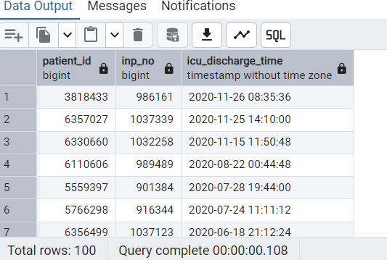

62. Create a role that cannot create other roles and expires on 12/31/24.

**QUERY:**

DROP ROLE IF EXISTS read_only_user;

CREATE ROLE read_only_user nocreaterole VALID UNTIL '2024-12-31';

**OUTPUT:**

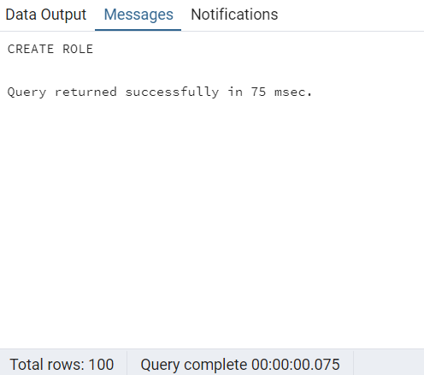

**Step 2:**

To check the read_only_user role is created and check whether there is no create role and the validity.

**QUERY:**

SELECT rolname, rolcreaterole, rolvaliduntil

FROM pg_roles

WHERE rolname = 'read_only_user';

**OUTPUT:**

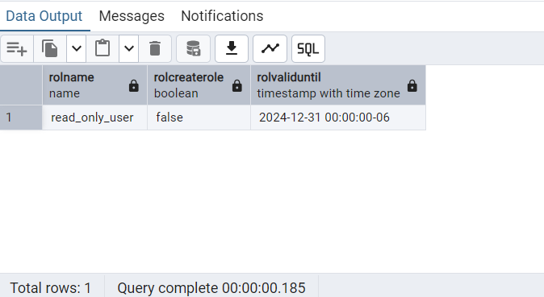

63. Find instances where a patient was transferred into the same

department twice within a day.

**QUERY:**

SELECT

patient_id,

transferdept,

CAST(starttime AS DATE) AS transfer_date,

COUNT(*) AS transfer_count

FROM transfer

GROUP BY

patient_id,

transferdept,

CAST(starttime AS DATE)

HAVING

COUNT(*) = 2

ORDER BY

transfer_date DESC;

**OUTPUT:**

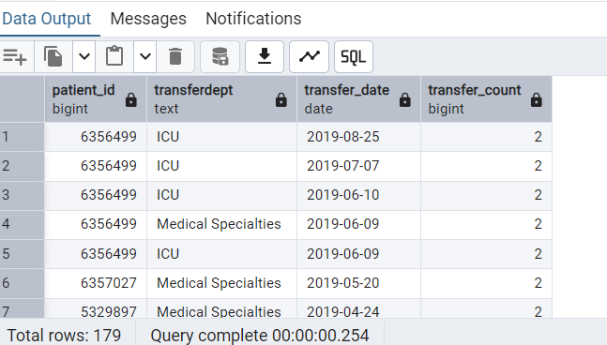

64. Use nested CTEs to calculate the median temperature of patients

over the 60 years old while in ICU.

**QUERY:**

WITH temperature_of_patients_above_60_in_ICU AS

(

SELECT nc.temperature

FROM nursingchart nc

JOIN baseline b ON nc.inp_no = b.inp_no

JOIN transfer t ON b.patient_id = t.patient_id

WHERE b.age > 60 AND t.transferDept = 'ICU'

)

SELECT PERCENTILE_CONT(0.5) WITHIN GROUP (ORDER BY temperature) AS median_temperature

FROM temperature_of_patients_above_60_in_ICU;

--The percentile_cont() function returns an interpolated value between multiple values based on the distribution.

--It is more accurate, but it may return a fractional value between two values in the input set.

**OUTPUT:**

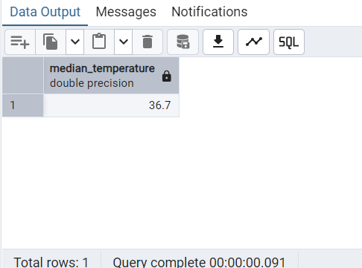

65. Show the average sodium value for each patient.

**QUERY:**

SELECT ba.patient_id, la.inp_no, la.category,la.item, AVG(la.labvalue :: decimal) as avg_sodium_value

FROM lab la

JOIN baseline ba ON ba.inp_no = la.inp_no

WHERE la.item LIKE 'Sodium (NA)%'

AND la.labvalue NOT LIKE '?%'

GROUP BY ba.patient_id, la.inp_no, la.category, la.item

ORDER BY avg_sodium_value;

To Convert the String into Number Eg: AVG(CAST(la.labValue as decimal))

AVG(la.labvalue :: decimal)

AVG(la.labvalue :: double precision) We need

to use double precision instead double

**OUTPUT:**

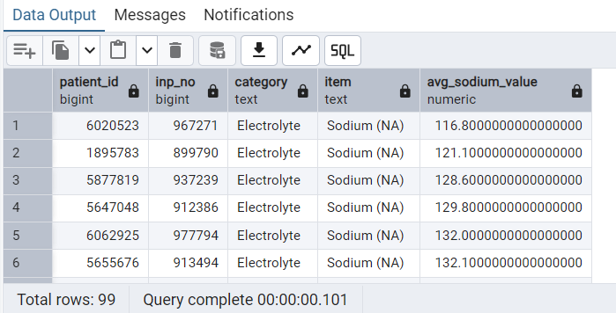

66. For each department show the count of patients whose condition

got worse a year after discharge.

**QUERY:**

SELECT discharge_dept, COUNT(patient_id)

FROM outcome

WHERE sf36_oneyearcomparehealthcondition LIKE '5_Much worse now than one year ago%'

GROUP BY discharge_dept;

**OUTPUT:**

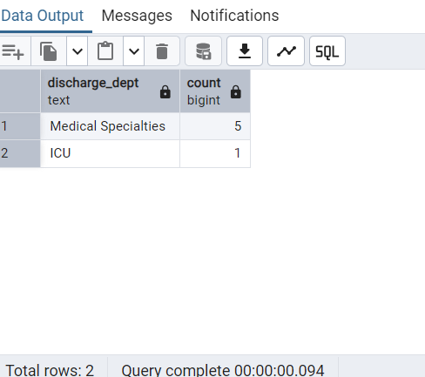

67. Identify the patients who have the same systolic blood pressure values

recorded for more than two consecutive days.

**QUERY:**

WITH consecutive_days_bp AS (

SELECT

inp_no,

DATE(charttime) AS reading_date,

blood_pressure_high,

LAG(DATE(charttime)) OVER (PARTITION BY inp_no ORDER BY DATE(charttime)) AS one_day_ago_date,

LAG(blood_pressure_high) OVER (PARTITION BY inp_no ORDER BY DATE(charttime)) AS one_day_ago_bp_high,

LAG(DATE(charttime), 2) OVER (PARTITION BY inp_no ORDER BY DATE(charttime)) AS two_days_ago_date,

LAG(blood_pressure_high, 2) OVER (PARTITION BY inp_no ORDER BY DATE(charttime)) AS two_days_ago_bp_high

FROM nursingchart

WHERE blood_pressure_high IS NOT NULL

)

SELECT

inp_no,

reading_date,

blood_pressure_high,

one_day_ago_date,

one_day_ago_bp_high,

two_days_ago_date,

two_days_ago_bp_high

FROM consecutive_days_bp

WHERE

-- Ensure the dates are consecutive

one_day_ago_date = reading_date - INTERVAL '1 day'

AND two_days_ago_date = reading_date - INTERVAL '2 day'

AND blood_pressure_high = one_day_ago_bp_high

AND blood_pressure_high = two_days_ago_bp_high -- Check if the consecutive days bp readings are same

**OUTPUT:**

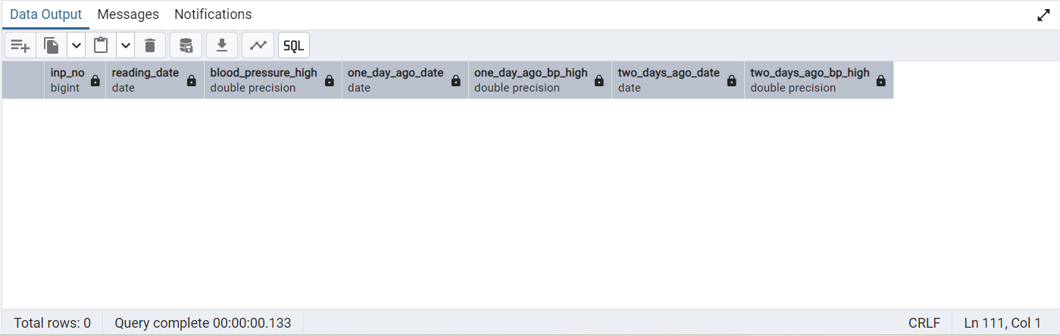

68. Show the 9th youngest patient and if they are alive or not.

**QUERY:**

WITH ninth_youngest_patient AS (

SELECT patient_id, age

FROM baseline

ORDER BY age ASC, patient_id ASC

LIMIT 1

OFFSET 8

)

SELECT n.patient_id,age,follow_vital

FROM outcome o

JOIN ninth_youngest_patient n ON o.patient_id = n.patient_id;

-- Limit 1 OFFSET 8 is used to take the 9 th row of the result set.

-- OFFSET says to skip that many rows before beginning to return rows.

-- LIMIT 1 : - Return the 1 row.

-- OFFSEET 8 : - It will skips the first 8 rows of the result set.

**OUTPUT:**

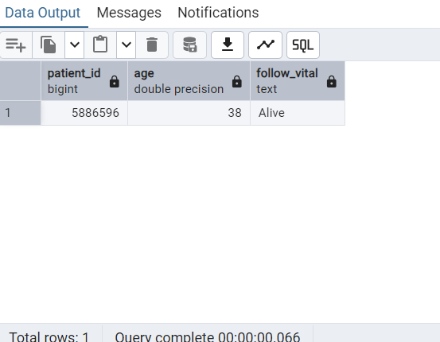

69. Show the bar distribution of ventilator modes for Pneumonia patients.

Hint: Do not consider null values.

**QUERY:**

SELECT n.breathing_pattern, COUNT(DISTINCT patient_id) AS patient_count

FROM baseline b

JOIN nursingchart n on b.inp_no = n.inp_no

WHERE infectionsite = 'Pneumonia'

AND breathing_pattern IS NOT NULL

GROUP BY n.breathing_pattern;

**OUTPUT:**

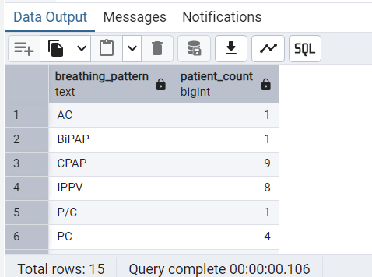

70. Create a view on baseline table with a check option on admit

department .

**QUERY - 1**

DROP VIEW IF EXISTS baseline_view;

CREATE VIEW baseline_view AS

SELECT patient_id, inp_no, age, sex, admitdept, infectionsite, icu_discharge_time

FROM baseline

WHERE admitdept = 'ICU'

WITH CHECK OPTION;

-- CHECK OPTION clause means to ensure that the changes to the base tables through

the view satisfy the view-defining condition.

--When you create a view WITH CHECK OPTION, PostgreSQL will ensure that you can

only modify data of the view that satisfies the condition in the view’s defining query

(query).

**OUTPUT - 1**

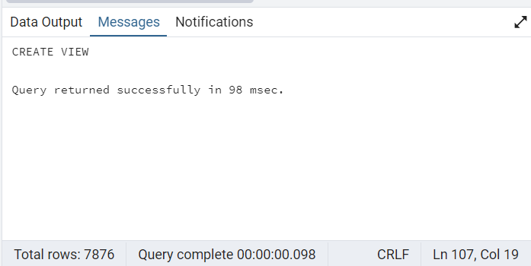

**QUERY - 2**

select * from baseline_view;

-- to view the baseline table only with admitdept= ICU, the created baseline_view is successful.

**OUTPUT - 2**

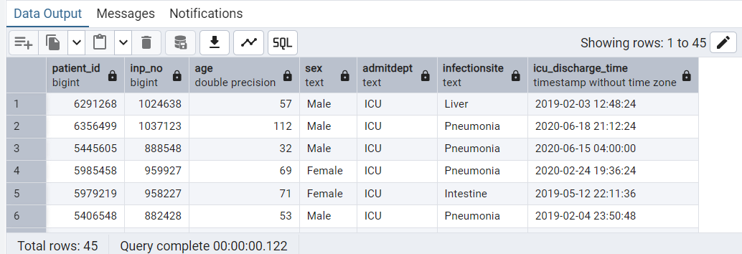

**QUERY - 3**

--Insert the data in to Baseline_View values

INSERT Into baseline_view (patient_id, inp_no, age, sex, admitdept, infectionsite, icu_discharge_time)

VALUES (50344432,3453344,45,'Female','ICU','Liver','2024-12-2 07:45:01');

**OUTPUT - 3**

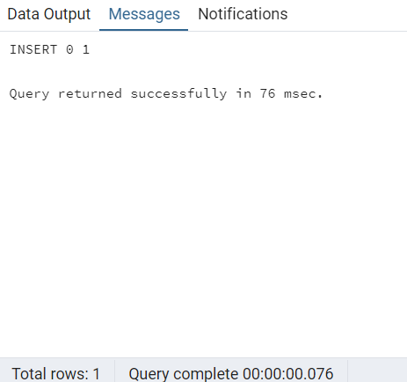

**QUERY - 4**

--Insert the invalid data in to Baseline_View values

INSERT INTO baseline_view (patient_id, inp_no, age, sex, admitdept, infectionsite, icu_discharge_time)

VALUES (50344433,3453345,46,'Female','Surgery','Liver','2024-10-4 08:45:01');

**OUTPUT - 4**

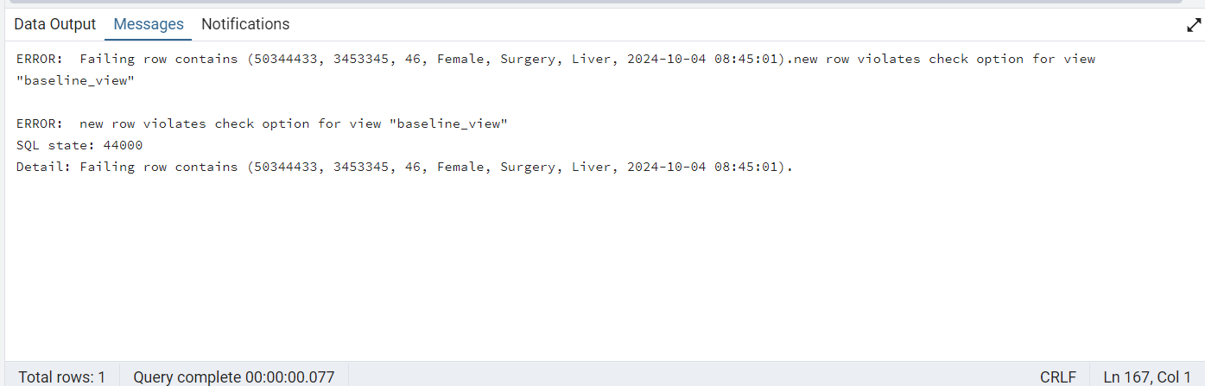

**QUERY - 5**

--Check Option after add the valid data.

SELECT * from baseline_view

WHERE patient_id='50344432';

**OUTPUT - 5**

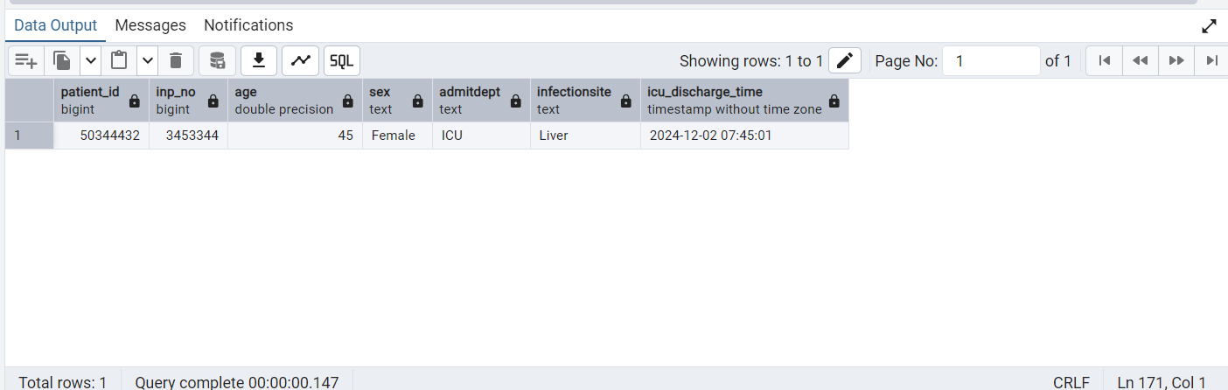

**QUERY - 6**

--Delete the patient_id = '50344432' from the baseline_view.

DELETE FROM baseline_view

WHERE patient_id = 50344432

AND inp_no = 3453344;

**OUTPUT - 6**

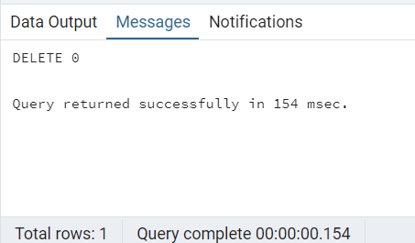

71. How many patients were admitted to Surgery within 30 days of getting

discharged?

**QUERY:**

SELECT COUNT(DISTINCT b.patient_id) AS patient_count

FROM baseline b

JOIN transfer t ON b.patient_id = t.patient_id

WHERE b.admitDept = 'Surgery'

AND t.starttime >= b.icu_discharge_time

AND t.starttime <= b.icu_discharge_time + INTERVAL '30 days';

**OUTPUT:**

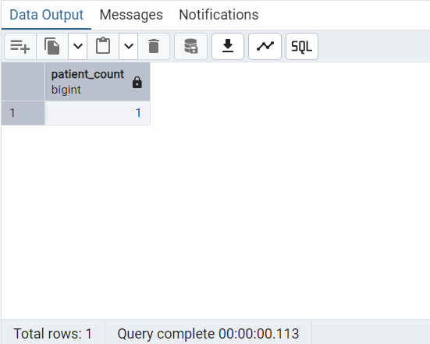

72. What percentage of the patients with blood oxygen saturation < 90 are

alive?

**QUERY:**

WITH low_oxygen_patients AS (

SELECT b.patient_id

FROM nursingchart nc

JOIN baseline b ON nc.inp_no = b.inp_no

WHERE nc.blood_oxygen_saturation < 90

),

low_oxygen_alive_patients AS (

SELECT COUNT(DISTINCT lop.patient_id) AS alive_count

FROM low_oxygen_patients lop

JOIN outcome o ON lop.patient_id = o.patient_id

WHERE o.follow_vital = 'Alive'

),

total_low_oxygen_patients AS (

SELECT COUNT(DISTINCT patient_id) AS total_count

FROM low_oxygen_patients

)

SELECT (a.alive_count * 100.0 / t.total_count) AS alive_percentage

FROM low_oxygen_alive_patients a

CROSS JOIN total_low_oxygen_patients t;

**OUTPUT:**

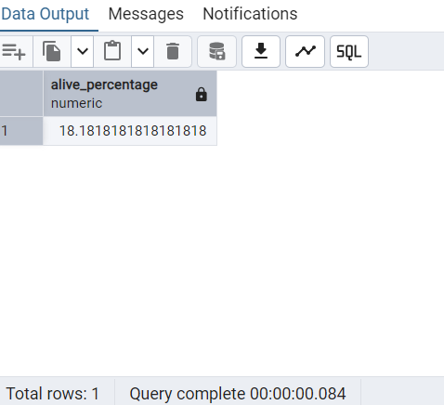

73. List the tables where column Patient_ID is present.(display column

position number with respective table also)

**QUERY:**

SELECT table_name, ordinal_position AS patient_id_column_position

FROM information_schema.columns

WHERE column_name = 'patient_id';

**OUTPUT:**

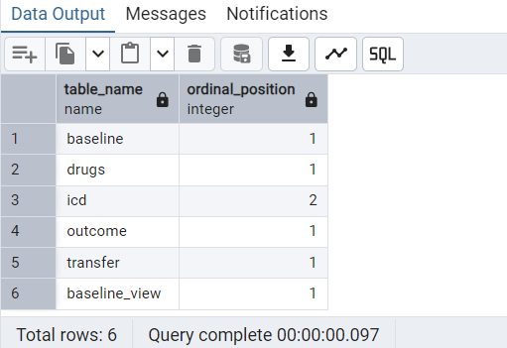

74. Find the average heart rate of patients under 40.

**QUERY:**

SELECT AVG(nc.heart_rate) as avg_heart_rate

FROM nursingchart nc

JOIN baseline b on nc.inp_no = b.inp_no

WHERE b.age < 40;

**OUTPUT:**

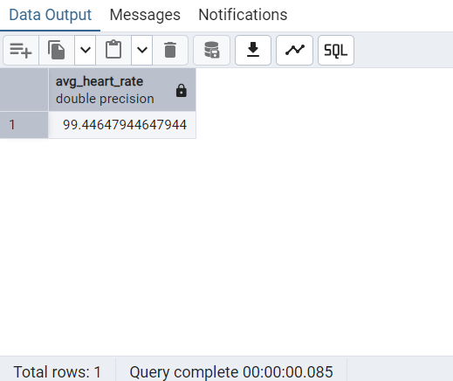

75. Use CTE to calculate the percentage of patients with hypoproteinemia

who had to be intubated.

**QUERY:**

WITH patients_with_hypoproteinemia AS (

SELECT DISTINCT inp_no

FROM lab

WHERE item LIKE '%Total protein (TP)%'

AND CAST(labvalue AS DOUBLE PRECISION) < 65 -- Patients with Total protein (TP) value less than the reference value 65 are taken as hypoproteinemia patients

),

patients_with_hypoproteinemia_intubated AS (

SELECT DISTINCT n.inp_no

FROM nursingchart n

JOIN patients_with_hypoproteinemia h ON n.inp_no = h.inp_no

WHERE endotracheal_intubation IS NOT NULL -- Patients with hypoproteinemia who had to be intubated

)

SELECT

COUNT(DISTINCT pwh.inp_no) AS patients_with_hypoproteinemia,

COUNT(DISTINCT hi.inp_no) AS patients_with_hypoproteinemia_intubated,

ROUND( COUNT(DISTINCT hi.inp_no) * 100.0 / COUNT(DISTINCT pwh.inp_no), 2) AS percentage_intubated

FROM patients_with_hypoproteinemia pwh

LEFT JOIN patients_with_hypoproteinemia_intubated hi ON pwh.inp_no = hi.inp_no;

**OUTPUT:**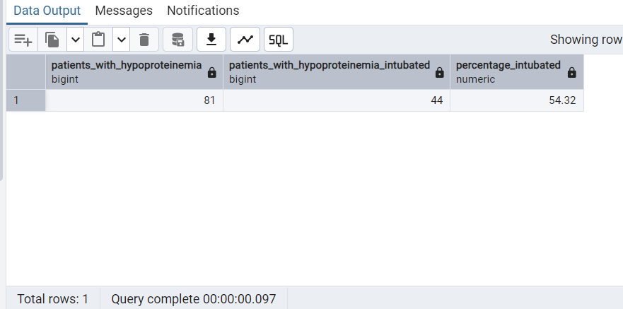

76. Identify patients whose breathing tube has been removed.

**QUERY:**

SELECT DISTINCT bl.patient_id, nc.inp_no, nc.extubation AS breathing_tube_removed

FROM nursingchart nc, baseline bl

WHERE bl.inp_no = nc.inp_no

AND nc.extubation = 'true'

ORDER BY bl.patient_id;

**OUTPUT:**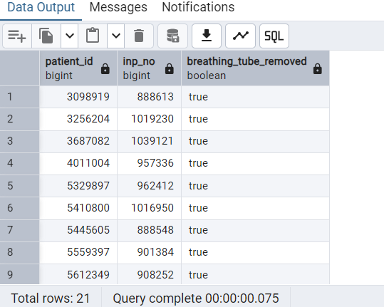

77. Compare each diastolic blood pressure value with the previous reading.

And show previous and current value.

**QUERY:**

SELECT bl.patient_id,

nc.inp_no,

nc.invasive_diastolic_blood_pressure AS blood_pressure_current_value,

LAG(nc.invasive_diastolic_blood_pressure)

OVER(

PARTITION BY bl.patient_id

ORDER BY nc.inp_no) AS blood_pressure_previous_value

FROM nursingchart nc

JOIN baseline bl ON bl.inp_no = nc.inp_no

WHERE nc.invasive_diastolic_blood_pressure IS NOT NULL

ORDER BY bl.patient_id;

**OUTPUT:**

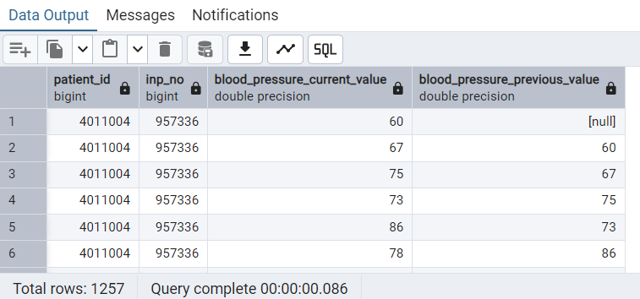

78. List patients who have more than 500 entries in the nursing chart.

**QUERY:**

SELECT bl.patient_id, COUNT (nc.inp_no) patient_entries

FROM nursingchart nc

JOIN baseline bl ON nc.inp_no = bl.inp_no

GROUP BY bl.patient_id

HAVING COUNT(nc.inp_no) > 500

ORDER BY patient_entries;

**OUTPUT:**

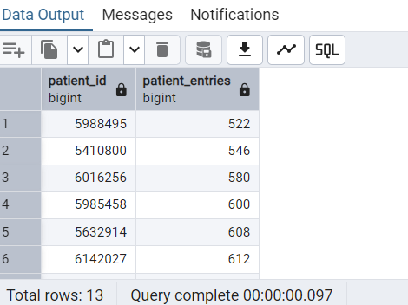

79. Display month name and the number of patients discharged from the

ICU in that month.

**QUERY:**

SELECT EXTRACT(MONTH FROM icu_discharge_time) AS month,

TO_CHAR(bl.icu_discharge_time,'Month') AS month_name,

COUNT(bl.patient_id)

FROM baseline bl

GROUP BY EXTRACT(MONTH FROM icu_discharge_time),TO_CHAR(bl.icu_discharge_time,'Month')

ORDER BY month;

**OUTPUT:**

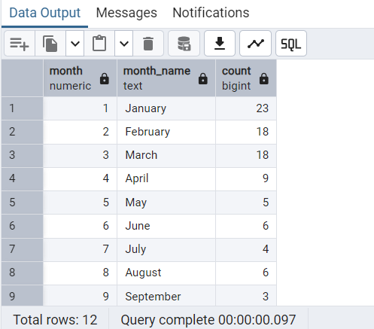

80. Write a function that calculates the percentage of people who had

moderate body pain after 4 weeks.

**QUERY:**

CREATE OR REPLACE FUNCTION calculate_moderate_pain_percentage()

RETURNS NUMERIC AS $$

DECLARE

total_patients INT;

moderate_pain_patients INT;

percentage NUMERIC;

BEGIN

-- Total number of patients

SELECT COUNT(DISTINCT patient_id) INTO total_patients

FROM outcome;

-- Number of patients with moderate pain after 4 weeks

SELECT COUNT(*) INTO moderate_pain_patients

FROM outcome

WHERE SF36_Pain_BodyPainPast4wk ='4_Moderate';

-- Calculate the percentage

percentage := (moderate_pain_patients::NUMERIC / total_patients) * 100;

RETURN percentage;

END;

$$ LANGUAGE plpgsql;

**OUTPUT:**

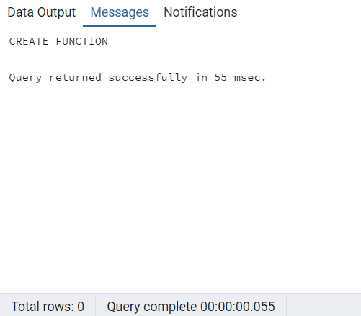

**QUERY:**

To view the function that calculates the percentage of people who had the moderate pain.

SELECT calculate_moderate_pain_percentage();

**OUTPUT:**

